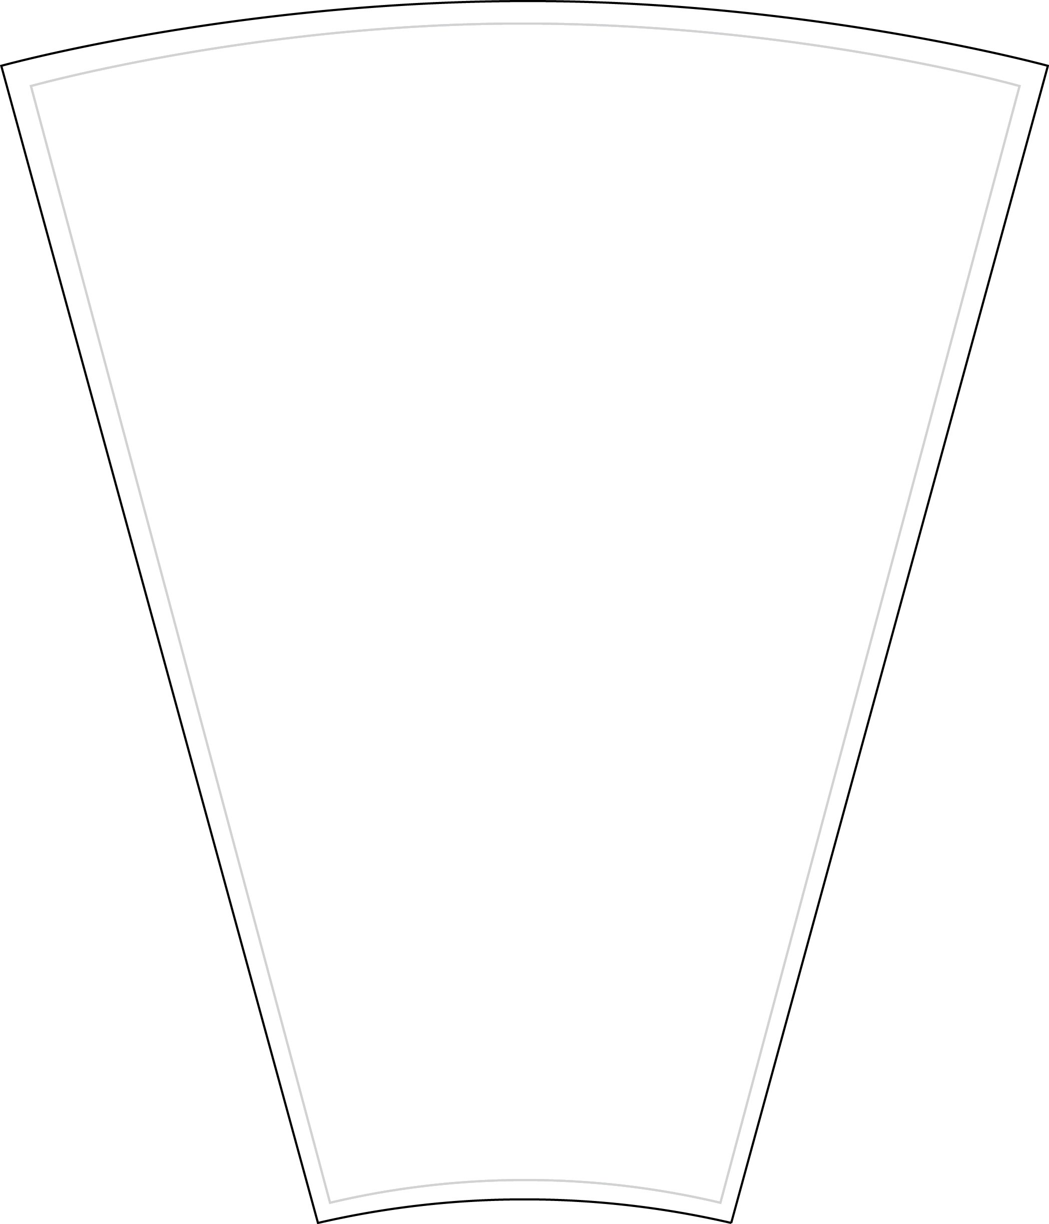
31 inch – 12-24 Slot
Full Insert
- Customize the inserts
- Print on 8.5 x 11 paper
- Cut on dotted line.
TEXT

