
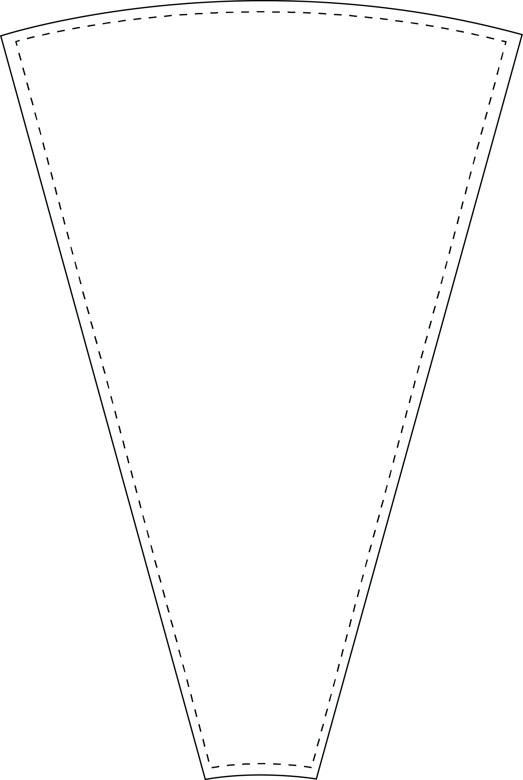
26 inch - 12 Slot Wheel
- Customize insert.
- Print on 8.5 x 11 paper.
- Cut on dotted line.
- Have FUN!!!
TEXT

