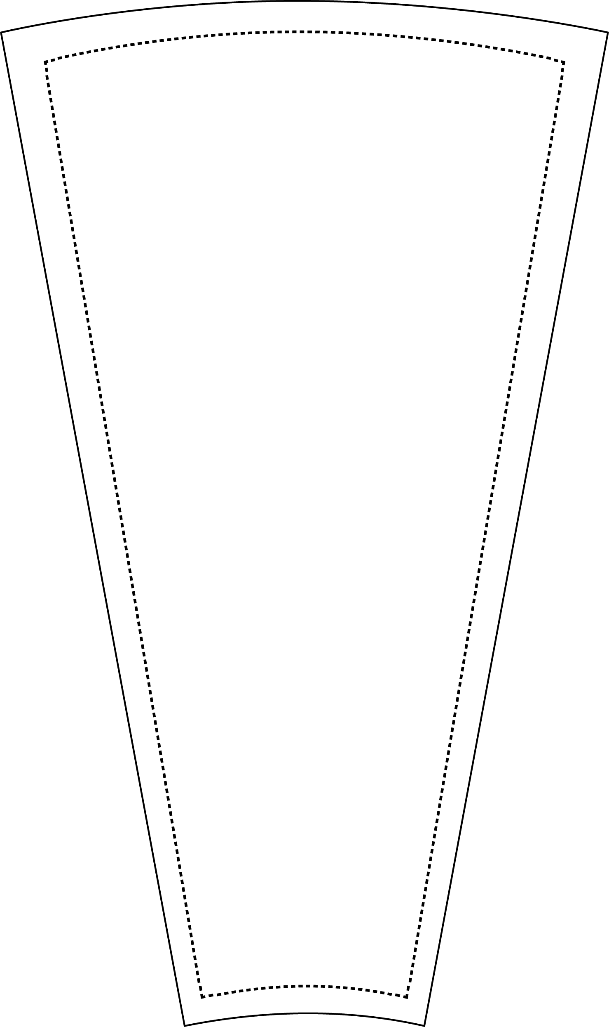

31 inch - 18 Slot
- Customize the inserts
- Print on 8.5 x 11 paper
- Cut on dotted line.
TEXT

