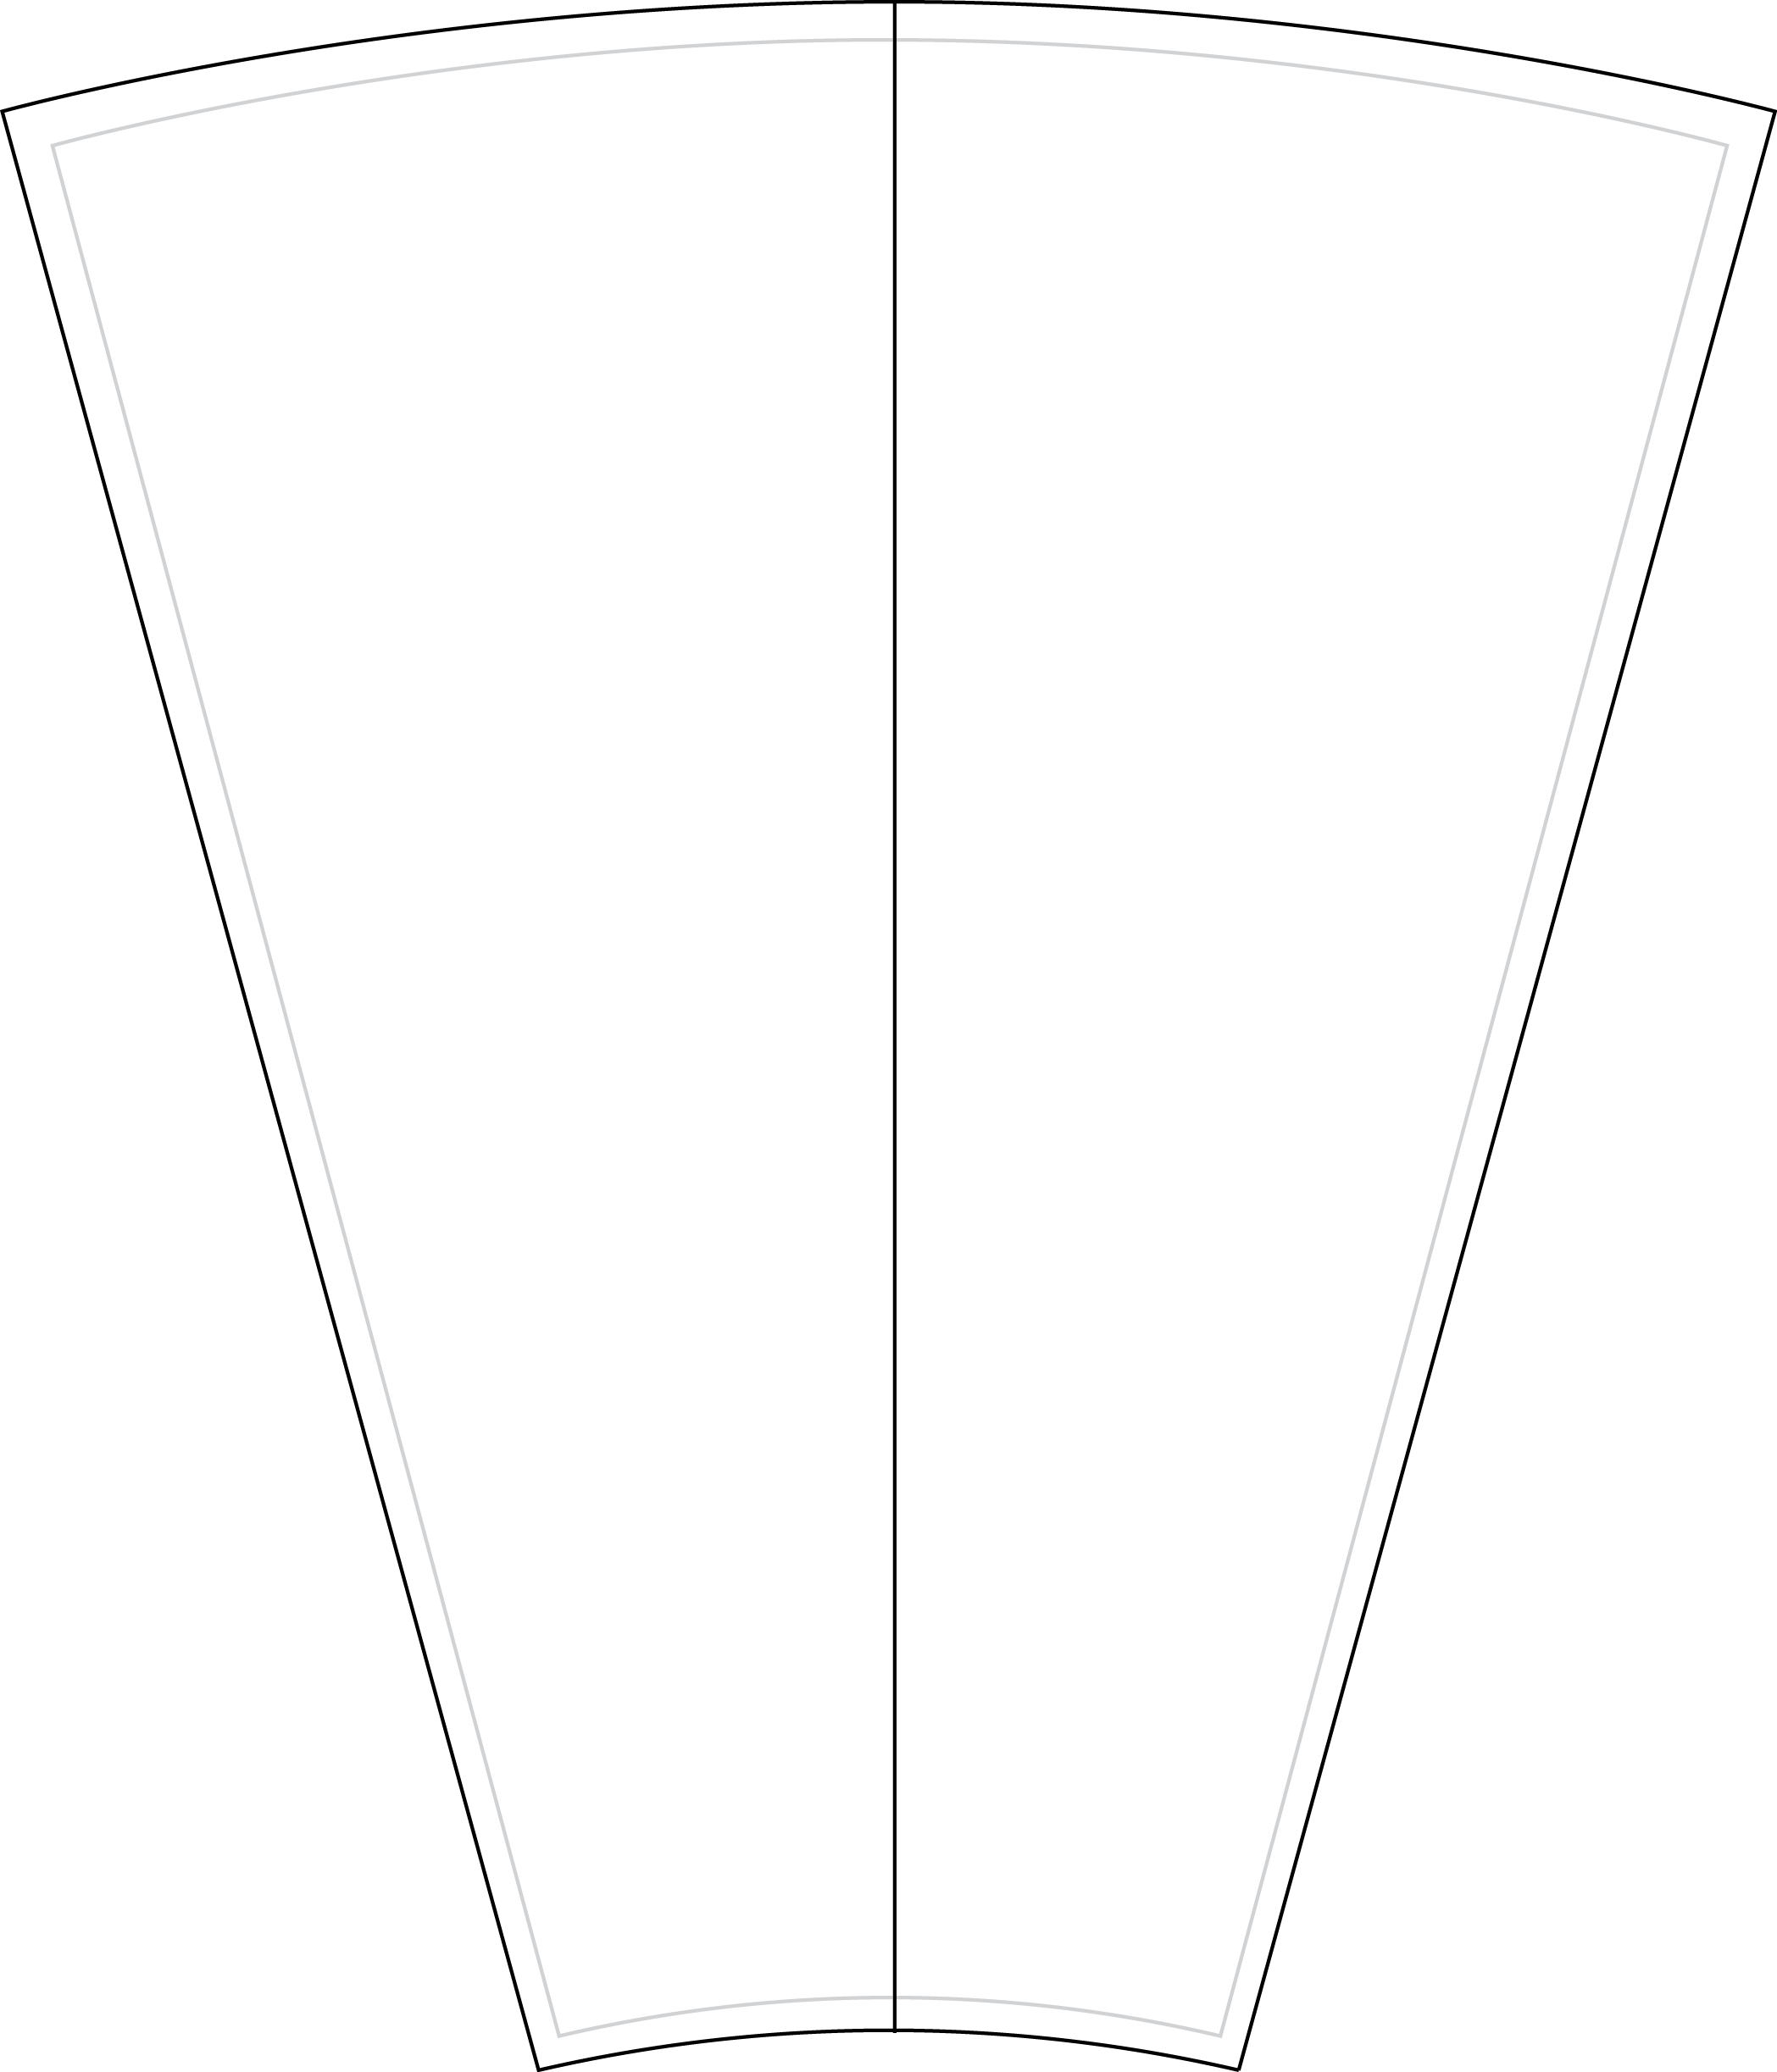
31 inch – 12-24 Slot
Half Insert
- Customize the inserts
- Print on 8.5 x 11 paper
- Cut on dotted line
TEXT
TEXT

